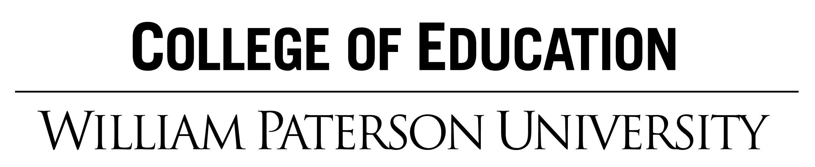

Name: Grade:

Central Focus: Concept:

Date of Lesson:

NJSLS Standards for Music: | Learning Objective(s):  Students will be able to  (For instrumental music, include at least one objective each for pitch, rhythm, style, technique, ensemble, and context.) | Assessment(s): (attach assessment tools and rubrics)
NJSLS Standards for Music: |  | College and Career Ready Practices: Identify the college & career ready practice you will introduce or build upon during this lesson.
Planning the Lesson (information to support the lesson and allow adequate planning):
- Teacher Resources (internet sites, technology/visuals, recordings, music):
- Academic Vocabulary and Language Function:
- Materials (e.g. books, recordings, technology, instruments, etc.):
- Cite Sources (e.g. textbook page or website):
- Cite principles from educational theory and/or research:
- Student prior knowledge needed:

Instruction: Teaching the Lesson (the actual process of instructing the class/students)
- Engage: Motivate/Introduce (How will you engage and support students to create, perform, or respond to music by developing and applying knowledge/skills, contextual understandings, and artistic expression related to the topic/song/composition/activity?)

- Procedure: Instruct (A numbered, sequential list delineating how learning tasks will be presented from the beginning to the end of the lesson. Include questions as well as students’ activities/involvement. It is NOT necessary to use complete sentences.

- Embedded assessment: (Describe how you will determine that students have learned? Label embedded assessments as PA (pre-assessment), IA (informal or formative assessment), FA (formal or quantitative assessment) and SA (summative assessment)

- Closure:

Differentiated instruction (How will you differentiate content, procedures, and assessments for special needs students?)

Assessment: Analyzing student learning and reflecting on teaching
- Assessment
    - Quantitative Assessment: A rubric or other quantitative instrument for each learning objective. Differentiate for students with special needs.
      - Number of students who completed the assessment task
      - Number and percentage of students who were proficient, satisfactory or needed improvement
    - Qualitative Evaluation: A description of how understandings, misunderstandings, and/or partial understandings ... explain the patterns of learning suggested by your quantitative assessment.

- Reflection/Self Evaluation
    - What impact did this lesson have on learners? What patterns of learning do you find in knowledge/skills, contextual understandings, and artistic expression across the class?
    - What can you do to improve this lesson and what are the implications for future lessons?
    - How does this lesson improve your teaching practice?

